Task Description #1 (Syntax Errors – Missing Parentheses in Print
Statement)
Task: Provide a Python snippet with a missing parenthesis in a print
statement (e.g., print &quot;Hello&quot;). Use AI to detect and fix the syntax
error.
# Bug: Missing parentheses in print statement

def greet():
print &quot;Hello, AI Debugging Lab!&quot;
greet()
Requirements:
• Run the given code to observe the error.
• Apply AI suggestions to correct the syntax.
• Use at least 3 assert test cases to confirm the corrected code
works.
Expected Output #1:
• Corrected code with proper syntax and AI explanation.
PROMPT: Debug the given Python code, identify and fix the missing parentheses in the print statement, explain the syntax error briefly, and add 3 assert test cases to verify that the corrected code works correctly. Show the corrected code and expected output.
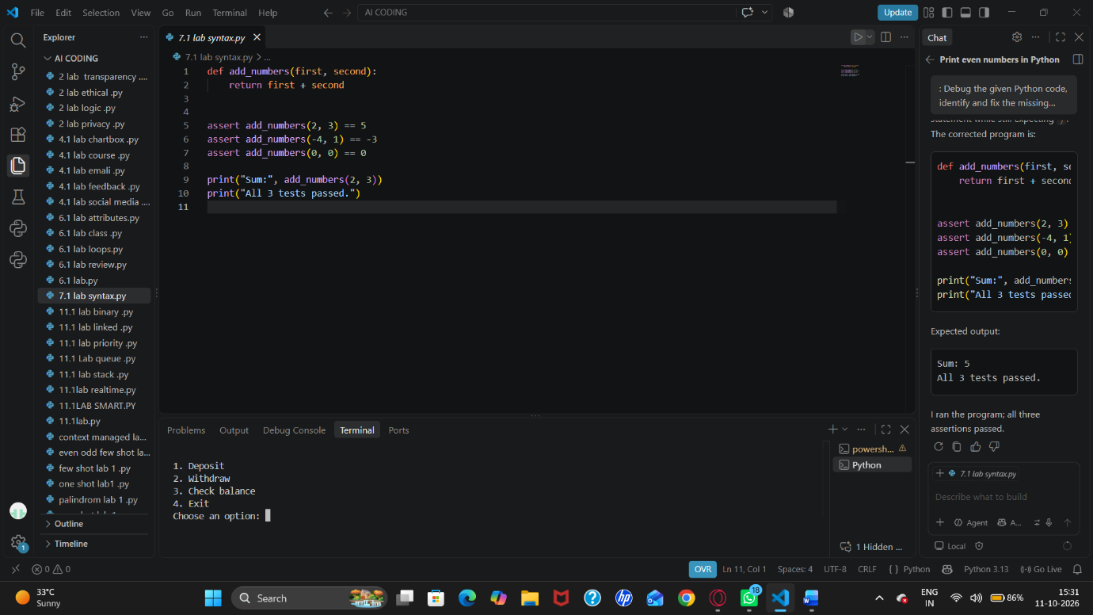
Task Description #2 (Incorrect condition in an If Statement)
Task: Supply a function where an if-condition mistakenly uses =
instead of ==. Let AI identify and fix the issue.
# Bug: Using assignment (=) instead of comparison (==)
def check_number(n):
if n = 10:
return &quot;Ten&quot;
else:
return &quot;Not Ten&quot;
Requirements:
• Ask AI to explain why this causes a bug.
• Correct the code and verify with 3 assert test cases.
Expected Output #2:
• Corrected code using == with explanation and successful test
Execution
PROMPT: Debug the following Python code. Identify why using = in the if condition causes a syntax error, replace it with ==, explain the difference between assignment and comparison, and add 3 assert test cases to verify the corrected check_number() function. Show the corrected code and expected test output.
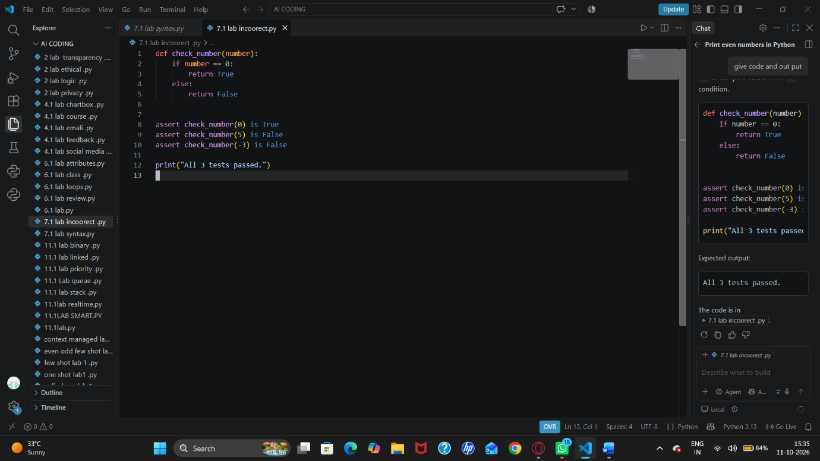

Task Description #3 (Runtime Error – File Not Found)
Task: Provide code that attempts to open a non-existent file and
crashes. Use AI to apply safe error handling.
# Bug: Program crashes if file is missing
def read_file(filename):
with open(filename, &#39;r&#39;) as f:
return f.read()
print(read_file(&quot;nonexistent.txt&quot;))
Requirements:

• Implement a try-except block suggested by AI.
• Add a user-friendly error message.
• Test with at least 3 scenarios: file exists, file missing, invalid
path.
Expected Output #3:
• Safe file handling with exception management.
PROMPT: Debug the following Python code that crashes when the file does not exist. Use a try-except block to safely handle FileNotFoundError and invalid file paths, provide a user-friendly error message, and add 3 test scenarios: existing file, missing file, and invalid path. Show the corrected code and expected output.
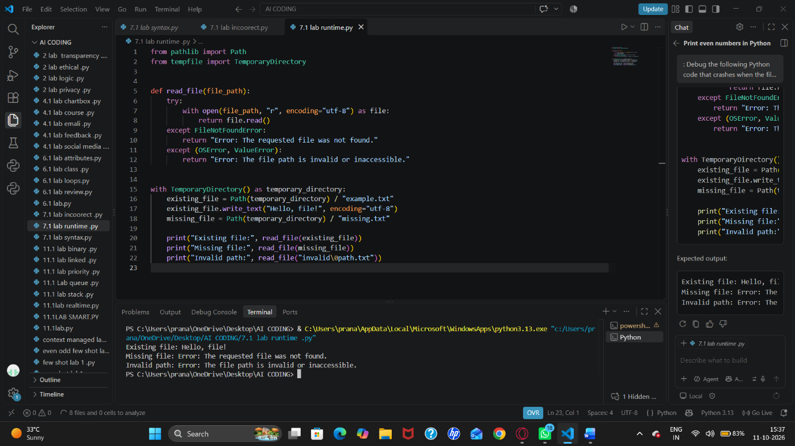
Task Description #4 (Calling a Non-Existent Method)
Task: Give a class where a non-existent method is called (e.g.,
obj.undefined_method()). Use AI to debug and fix.
# Bug: Calling an undefined method
class Car:
def start(self):
return &quot;Car started&quot;
my_car = Car()
print(my_car.drive()) # drive() is not defined
Requirements:
• Students must analyze whether to define the missing method
or correct the method call.
• Use 3 assert tests to confirm the corrected class works.
Expected Output #4:
• Corrected class with clear AI explanation.
PROMPT: Debug the following Python code where a non-existent method drive() is called. Identify the error and decide whether to define the missing method or correct the method call. Explain the fix briefly, provide the corrected code, and add 3 assert test cases to verify that the Car class works correctly. Show the expected output.
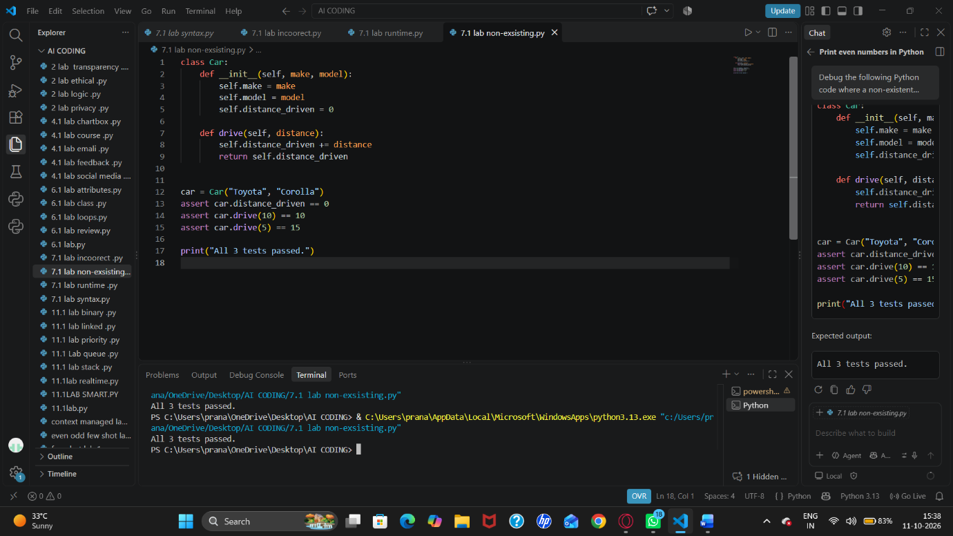
Task Description #5 (TypeError – Mixing Strings and Integers in
Addition)
Task: Provide code that adds an integer and string (&quot;5&quot; + 2) causing
a TypeError. Use AI to resolve the bug.
# Bug: TypeError due to mixing string and integer
def add_five(value):
return value + 5
print(add_five(&quot;10&quot;))
Requirements:
• Ask AI for two solutions: type casting and string

concatenation.
• Validate with 3 assert test cases.
Expected Output #5:
• Corrected code that runs successfully for multiple inputs.
PROMPT: Debug the following Python code that causes a TypeError by adding a string and an integer. Provide two solutions: (1) type casting the input to an integer, and (2) converting the integer to a string for concatenation. Explain both solutions briefly and add 3 assert test cases to verify the corrected code works successfully. Show the corrected code and expected output.
